|  |
| --- |
| Air Pollution in Chiang Mai, Thailand |
|  |
| **May 24**  Authored by: Worasom Kundhikanjana |

# Key Messages

In this report, we studied air pollution in Chiang Mai, Thailand. The major pollutants are PM2.5 and PM10. The pollutions are high during the winter season (October – April). Factors contributed to the pollutions level, such as weather patterns, the effect of global warming, and agricultural burning are considered.

The first section of this report provides a geographical background of the Chiang Mai. In section 2, we first understand the behaviors of different pollutants and their relationships. In section 3-4, the effect of weather patterns, fire hotspots, and human activities are studied. These sections will serve as a robustness check for our machine learning model.

The last section provides detail about the definition of AQI, data sources, and how the data are put together for modeling.

Contents

Air Pollution in Chiang Mai, Thailand 1

Key Messages 2

1 About Chiang Mai 6

1.1 Geography 6

1.2 Pollution Monitoring Stations 7

2 Air Pollutions Data 8

2.1 Air Pollution Overtime 8

9

10

2.2 Winter Season 10

2.3 Air Pollution Overtime 11

2.4 Correlation Between Pollutants 12

3 Effect of Weather Pattern 13

3.1 Effect of Temperature 13

3.2 Effect of Wind Direction 14

4 Agricultural Burning 14

14

15

5 Technical Details 15

5.1 Definitions of AQI 15

5.2 Weather Data 16

5.3 Hotspot Data 17

5.4 Other Data 17

# About Chiang Mai

## Geography

Chiang Mai one of the biggest cities in the northern part of Thailand. Figure 1 shows a map of Chiang Mai and the surrounding province. Chiang Mai also shares a border with Myanmar in the northwestern direction. Laos is located in the northeastern direction. China is in the north with Yunan as the nearest big city. These neighbors countries still practice agricultural burning, which could be a contributing factor for air pollutions.

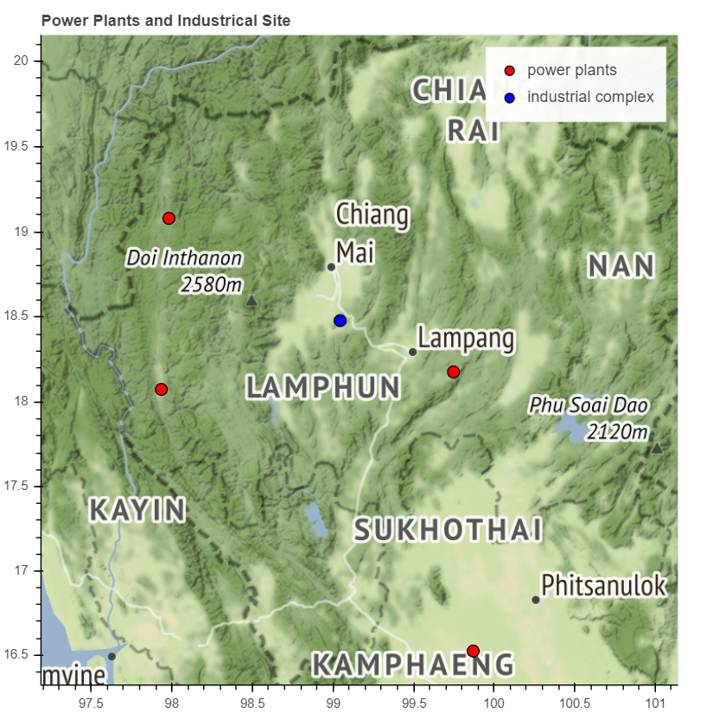

Figure 1: map of Chiang Mai with nearby industrial complex and power plants, which could potentially generate pollutions. The dashed line indicates the Thailand-Myanmar border.

Notice that Chiang Mai is a valley surrounded by high mountain ranges, thus stagnant air and extreme weather patterns could have a multiplication effect on the existing air pollution problems.

There are four power plants in Chiang Mai neighbor provinces as shown as red dots in Figure 1. The controversial coal power plant is in Mae Moh, Lampang, which is about 50 km. These power plants used to cause air pollution problems especially sulfur dioxide pollutants. Currently, the Electricity Generating Authority of Thailand states that this problem has been resolved by adding an air filtration system from 1995 – 1998. The other three power plants are oil and natural gas power plants.

The closet industrial complex is shown as a blue dot in Figure 1. It is 25 km away from downtown Chiang Mai. The type of industries in this region is food, sugar, and jewelry industries. There are also electronics industries.

## Pollution Monitoring Stations

Figure 2 and **Error! Reference source not found.** are maps of the pollution monitoring stations. In Thailand, the Pollution Control Department (PCD) is in charge of monitoring pollutions. PCD has two monitoring stations both in the downtown area shown as magenta dots in Figure 2 and. The station in the north is near the City Hall, and the station in the south is by Yupparaj Wittayalai School. These stations start collecting the data since June, 1995 with measurement of carbon monoxide gas (CO), ozone (O3), nitrogen dioxide (NO2), sulfur dioxide (SO2), and coarse particle pollutant (PM10). These stations started monitoring small particle pollution (PM2.5) at different times in mid-2005 (Yupparaj Wittayalai School station) and mid-2016 (City Hall station). Because the major air pollution problem in Chiang Mai is from small particle pollution. We will focus on analyzing the data from Yupparaj Wittayalai School station.

Since mid-2018, Chiang Mai University started setting up monitoring stations across Chiang Mai shown as yellow dots in Figure 2 and. These stations focus on measuring the particle pollutions, i.e. PM2.5 and PM10. So far, there are about 40 monitoring stations across the downtown area and outside the city. These stations can provide a spatial map of the pollutions and their relationship with local traffic.

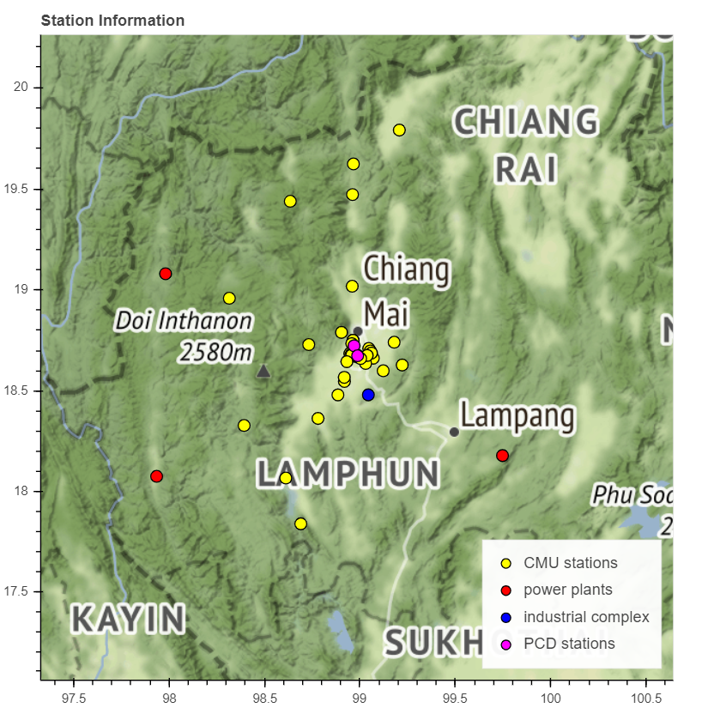

Figure 2: a map of pollution monitor stations in Chiang Mai, nearby industrial complex and power plants

# Air Pollutions Data

## Air Pollution Overtime

Figure 3 and Figure 4 show hourly pollution levels from Yupparaj Wittayalai School station since 1996. The pollutants with the most AQIs are in Figure 3 with the worse value for PM2.5, PM10, and O3 accordingly. These values often exceed an unhealthy level (AQI=150) and sometimes reach a very unhealthy level (AQI>200) in winter. For the other pollutants, CO, NO2, and SO2, the pollution levels are well within the good-moderate limit.

# 

Figure 3: Daily maximum pollution level for PM2.5, PM10, and O3 from Yupparaj Wittayalai School station. The pollution levels have a seasonal pattern with high values in winter. In 2011, 2016and 2017, the pollution levels are relatively low. The horizontal yellow, red and purple lines indicate the transition to moderate, unhealthy, and very unhealthy levels accordingly.

Note that, for PM2.5, the data is missing between 2007 and 2011. Including the PM2.5 before 2007 could affect the accuracy of the model, thus the values after 2011 should be used for modeling. Alternatively, one could build a model for PM10 and infer PM2.5 from the PM10 value. Interestingly, in 2011, 2017, and 2018 the air pollution levels for PM2.5, PM10, and O3 are noticeably lower. These years could serve as case studies to identify major pollution sources.

# 

Figure 4: Daily maximum pollution levels for CO, NO2, and SO2 from Yupparaj Wittayalai School station. The horizontal yellow and red lines indicate the transition to moderate and unhealthy levels accordingly.

## Winter Season

Official winter season start on a different day every year. Here, we define our winter months from the seasonal pattern of PM2.5 level. Figure 5 plots the daily average of PM2.5 levels for a different year. The solid blue line is the average of the same day of year for different years. This average value exceeds the healthy limit between December and April. We define the winter season to be between 1sth December and April 30th. This season will be used to calculate the yearly trends in the later part of the report. Moreover, the average seasonal pattern in Figure 5 will be compared with the wind and hotspots pattern in Figure 8, Figure 10, and Figure 11.

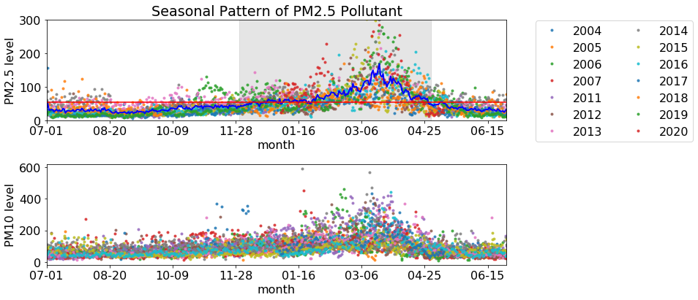

Figure 5: Daily average of PM2.5 level in a different year. The solid blue line is the average pollution level for the same day of year. The average reaches an unhealthy limit (horizontal red line) between December – April. These defined the winter season in this report.

## Air Pollution Overtime

For the reason justified in section 2.4, PM10 levels can be used to represent the trend of the pollution level over time. Figure 6 plot the average PM10 levels during the winter season over the year. Although the average level has decreased slightly from 1995. The average from 2004 to the average values fluctuates between 80 and 45, which are in a good AQI level. In short, this indicates no major improvement nor worsening of the situation. We emphasize that the low yearly average values are often misleading because they are much lower than the hourly or daily average values, which can reach an unhealthy limit.

Note that the years with low pollution level (2011,2017, 2018) in Figure 3 is shifted by one number in Figure 6. This is because the low number is from the winter of 2010, which also covers the early months of 2011.

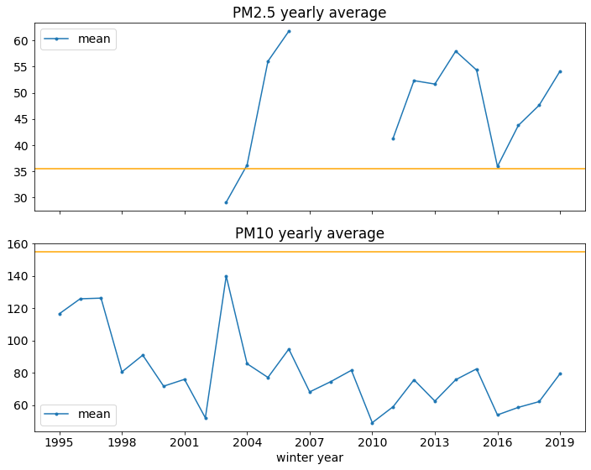

Figure 6: a yearly average of PM10 value for different winter years. Winter year accounts for the data between December and April of the next year. For example, the winter year 2016 means the data between December, 2016 and April 2017. The yellow line indicates the transition from a good to a moderate limit. The low pollution seasons are the winters of 2010, 2016, and 2017.

## Correlation Between Pollutants

Except for SO2, the pollutions have a seasonal pattern with high value during winter (Oct – April), and their levels are highly correlated. This is shown by the plot of correlation coefficients among the pollutants in Figure 7. PM2.5, PM10, NO2, and O3 have correlation coefficients above 0.5. The same seasonal patterns and the high correlation coefficients indicate similar chemical composition of the air pollutions, which in turn suggests that air pollutions may be generated from the same reoccurring sources.

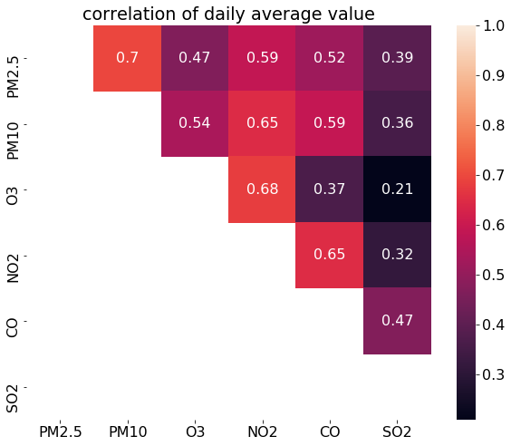

Figure 7: Spearman correlation coefficient among pollutants. Red color indicates high correlation coefficients, which are the cases for PM2.5, PM10, NO2, and O3.

The high correlation behavior among the pollutants also helps infer the missing data. As mention earlier, PM10 can be used to infer PM2.5. Besides, since the NO2 concentrations can be seen from the satellites, such a map can also be used to understand the spatial distribution of the particle pollutions.

A closer look at the peak value of each pollutant indicates slightly different rising and falling patterns. Figure 8 shows the average rising and falling behavior of different pollutants during the winter season. The y-axis values are the pollution level normalized by the maximum value for each pollutant. This normalization allows a comparison between pollutants. All pollutants except for SO2, have a clear seasonal pattern with a peak in March. PM2.5 levels rise more sharply starting early January, while for the other pollutants, the levels gradually rise from early October. All pollutant levels drop sharply in April.

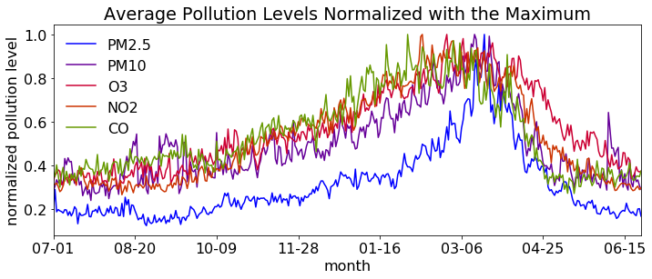

Figure 8: Day of year averages show rising and falling behaviors for different pollutants in the winter season. The plot omitted the SO2­ level, which does not have a significant seasonal pattern. The level is normalized by the maximum average maximum value.

# Effect of Weather Pattern

## Effect of Temperature

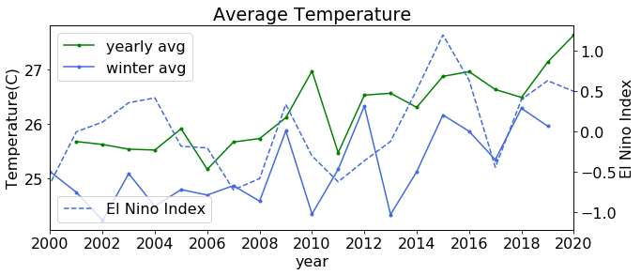

Figure 9: Yearly average temperatures in Chiang Mai since 2000. The green/blue lines are yearly, and seasonal averages. The dashed line is the average El Nino index for the winter season.

Figure 9 shows the yearly average temperature in Chiang Mai both the yearly average and the average for only winters have a rising trend. A small fluctuation in the temperature is due to the El Nino-La Nina effects as seen when plotting with the El Nino index. The average temperature and El Nino index correlate 0.4; however, since the average pollution levels do not show either increasing or decreasing trend, the temperature and El Nino index have a low correlation with the pollution level.

## Effect of Wind Direction

Air circulation is very important for reducing the pollution level. Chiang Mai is surrounded by a high mountain. In winter, average wind speed is about 5 km/hour, this number is higher when entering monsoon season. Figure 10 compares the average PM2.5 rising and falling pattern in winter with the average wind speed. The wind speed decreased drastically in November and increasing again in April. This might explain the sharps drop in the pollution level in April.

Laster, we will show that the hourly value of wind speed also affects the hourly pollution level.

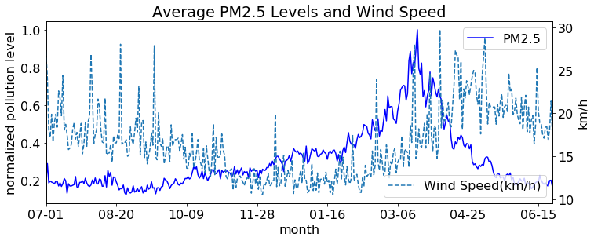

Figure 10: Comparison between the PM2.5 (solid line) and wind speed (dashed line) pattern in the winter season. The wind speed pattern is negatively correlated with the PM2.5 level (Spearman correlation coefficient = - 0.26)

# Agricultural Burning

## Strong Correlation between Particle Pollution Levels and Agricultural Burning.

Many countries in South East Asia still practices agricultural burning and winter is the burning season. Figure 11 shows satellite detected hotspots around Chiang Mai. These hotspots represent fire activities, which are likely from agricultural burning or wildfires. There are significant burning activities around the Chiang Mai in winter. There are dense burning activities in Myanmar and Laos, less activity in Thailand, and light activities in China. We will see that these activities are a major contributing factor in high particle pollution in Chiang Mai.

# 

Figure 11: Satellite detected hotspots in March 2019

Figure 12 compares the seasonal pattern of fire hotspots and those of the particle pollutions. The pattern highly correlated with the PM2.5 level (Spearman correlation coefficient = 0.9) with the highest burning activities in March. On average, the fire activities significantly drop in April. For PM10, the correlation coefficient = 0.7 due to the fast-rising pattern in early winter.

# 

Figure 12: Compare the seasonal pattern of the number of hotspots within 1000 km from Chiang Mai(red) and the particle pollutions (blue and purple). The number of hotspots has a similar pattern as the PM2.5’s with Spearman correlation coefficient = 0.9, while PM10 and the number of hotspots has correlation coefficient = 0.7.

The total number of hotspots in each season also determines the average pollution levels. Figure 13 compares the average particle pollution levels for the winter season and the number of hotspots. In the winter of 2010, 2016, and 2017 with relatively lower particle pollution levels, the number of hotspots is also lower.

# 

Figure 13: High correlation between the seasonal average PM10 and PM2.5 levels and the total number of fire hotspots in that season. In winter 2010, 2016, and 2017, the fire activities are significantly lower, thus lower pollution levels.

## Relationship with Human Activities

Fire activities seem to be related to human activities. Figure 14 shows the average hourly number of fire activities in a different hour of the day. Significantly higher fire activities occur between 9:00 – 15:00 suggesting that the hotspots are not from random fire activities, but man-made.

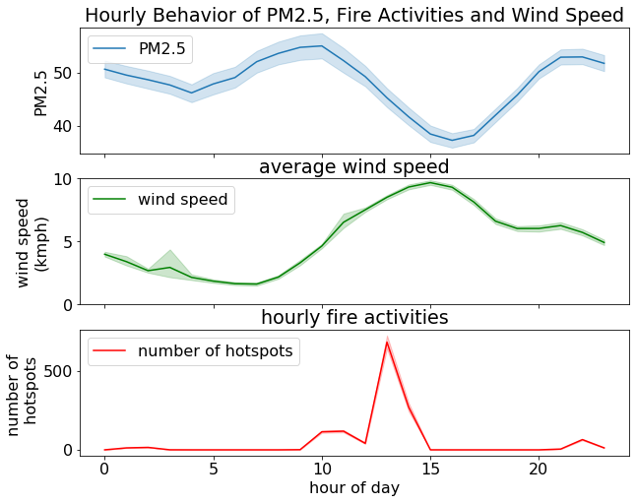

Figure 14: Average hourly Behavior of PM2.5 level, number of fire hotspots, and wind speed have patterns that related to the time of day.

# Technical Details

## Definitions of AQI

This report uses US AQI for pollution standards. Sometimes the local government pollution standard is lower compared to those in developed countries, therefore it is helpful to compare the US and Thailand AQI standards. Figure 13 compares the AQI standard for the US and Thailand for different pollutants. The pollution levels are on the horizontal axis, while the hazard levels are color-coded. For each pollutant, the corresponding AQI values do not scale linearly across different hazardous levels, but AQI below 50 means very good air quality, and above 200 AQI means unhealthy.

Although Thailand and the US have a slightly different cut off values. The values considered hazard level are in agreement for most pollutants, except for SO2. For SO2, the value 200 ppb is still considered healthy, while this exceeds the healthy limit for the US standard.

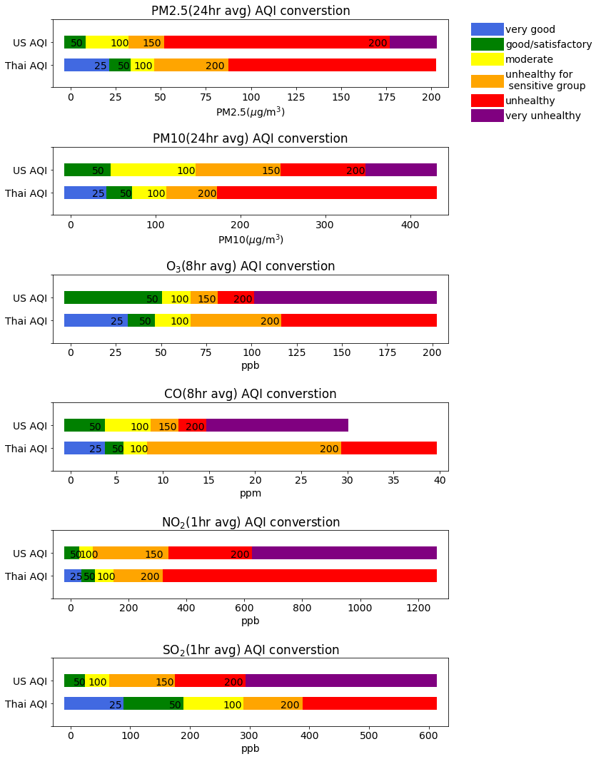

Figure 15: Comparison between US and Thailand AQI standards. The text on the plot indicates the maximum AQI for that range.

## Weather Data

Data preprocessing

## Hotspot Data

<https://earthdata.nasa.gov/earth-observation-data/near-real-time/firms/c6-mcd14dl>

## Other Data

US AQI standard <https://airnow.gov/index.cfm?action=airnow.calculator>

Thailand AQI standard <http://air4thai.pcd.go.th/webV2/aqi_info.php>

Holiday information in Thailand are from <https://www.timeanddate.com/holidays/thailand/>

El Niño index is from <https://origin.cpc.ncep.noaa.gov/products/analysis_monitoring/ensostuff/ONI_v5.php>